ZeroTrust Gateway
A Zero Trust Network Access (ZTNA) Platform
Built with Cloudflare Tunnel, oauth2-proxy, and Keycloak

Project Description
ZeroTrust Gateway is a cybersecurity-focused Zero Trust Network Access (ZTNA) platform designed to securely publish internal web applications without requiring a VPN, public firewall ports, or domain ownership. Built using Cloudflare Tunnel (cloudflared), oauth2-proxy, and Keycloak, the platform provides identity-gated access to internal applications through outbound-only connectivity and centralized authentication.
By combining secure tunneling with self-hosted identity management, ZeroTrust Gateway delivers a modern Zero Trust access model that eliminates broad network access and restricts users to authorized applications only — replacing the 'connect to the network, then trust everything' posture of a traditional VPN with 'verify identity, then grant access to exactly one application.'
Traditional VPN-based access grants broad network access the moment a user connects, and the VPN concentrator itself becomes an inbound attack surface. ZeroTrust Gateway inverts this model: nothing is exposed inbound, access is scoped to a single application, and identity is verified on every request via OpenID Connect (OIDC) rather than once at connection time.

Scenarios
Scenario 1: Publishing an Internal App Without Opening Firewall Ports
A small team needs to give a few people access to an internal admin tool that currently only works over VPN or on the local network. cloudflared is installed on the host and creates an outbound-only tunnel to Cloudflare's edge. The application becomes reachable at a public URL with zero inbound firewall rules and no domain purchase.
Scenario 2: Enforcing Login Before Any Request Reaches the App
Even though the tunnel makes the app publicly reachable, no one should be able to use it without authenticating first. oauth2-proxy is placed between cloudflared and the application. Every request is intercepted, redirected to Keycloak for login, and only forwarded upstream once a valid identity token exists — the application itself never has to implement authentication logic.
Scenario 3: Replacing a VPN for Remote Contractors
A remote contractor needs occasional access to one internal tool but should not receive broad network access the way a traditional VPN would grant. Because access is scoped to a single published route behind oauth2-proxy, the contractor can reach only that application after authenticating through Keycloak, with no visibility into or connectivity to any other host on the network.

Technical Architecture
ZeroTrust Gateway is organized into four layers, each with a single responsibility. All inbound connectivity is eliminated by design — the only active connection from the application host to the outside world is the outbound tunnel that cloudflared initiates.

Tunnel Layer (cloudflared / Cloudflare Edge)
cloudflared runs as a lightweight agent on the application host and establishes an outbound-only connection to Cloudflare's global edge network, issuing a public hostname that proxies traffic to a local port. No inbound firewall rule, port forward, or domain purchase is required.

Identity Gate Layer (oauth2-proxy)
oauth2-proxy sits between the tunnel and the protected application, configured as a generic OIDC client against Keycloak. Every incoming request is checked for a valid, signed session cookie; requests without one are redirected to Keycloak's login page. Only requests carrying a valid session are reverse-proxied to the upstream application.

Identity Layer (Keycloak)
Keycloak runs as the centralized Identity Provider (IdP). It manages user accounts and issues OIDC tokens to oauth2-proxy after successful login. A dedicated realm and confidential client keep this platform's authentication isolated from any other Keycloak workloads.

Application Layer
A protected internal web application runs on a local port with no exposed network interface and no authentication logic of its own. It trusts that any request reaching it has already been authenticated and authorized at the gateway, consistent with the Zero Trust principle of enforcing identity at the edge rather than in every application.

Who This Project Is For
ZeroTrust Gateway is a high-impact, hands-on build for anyone working at the intersection of identity, networking, and security. It is especially relevant for:
- Cybersecurity Engineers
- Network Security Engineers
- Identity and Access Management (IAM) Specialists
- Cloud Security Engineers
- DevSecOps Professionals
- Security Analysts
- Zero Trust Architects
- System Administrators

Pre-requisites

Skills Required
- Secure tunneling concepts (Cloudflare Tunnel / cloudflared)
- Identity and Access Management with Keycloak (realms, clients, OIDC)
- Reverse proxy and identity-gateway configuration (oauth2-proxy)
- OpenID Connect (OIDC) and OAuth 2.0 fundamentals
- Docker container fundamentals and Docker Compose

System Requirements

Hardware Requirements
- Processor: Intel Core i5 (8th Gen or above) / AMD Ryzen 5 or equivalent
- RAM: Minimum 8 GB (Recommended: 16 GB for multitasking and lab usage)
- Storage: 256 GB SSD (or 500 GB HDD minimum)
- Internet Connectivity: Stable high-speed internet connection (minimum 10 Mbps, recommended 20 Mbps)

Software Requirements
- Operating System: Windows 10 / 11, macOS (Monterey or later), or Linux (Ubuntu 20.04+)
- Web Browser: Latest version of Google Chrome, Mozilla Firefox, or Microsoft Edge
- IDE / Code Editor: Visual Studio Code (recommended) or any preferred IDE
- Version Control: Git (latest version, installed and configured)
- Docker Engine 24.x or later and Docker Compose v2.x or later
- cloudflared binary (Cloudflare Tunnel client)
- oauth2-proxy binary or Docker image
- Additional Tools: Python (version 3.8 or above), AWS CLI (latest version)

Project Workflow
Phase 1: Environment Setup & Zero Trust Infrastructure Configuration
Set up Docker, cloudflared, oauth2-proxy, and Keycloak. Deploy a protected internal web application for secure access testing. Configure outbound-only connectivity using Cloudflare Tunnel, establishing a secure infrastructure foundation for identity-driven application access.
Phase 2: Zero Trust Architecture Design & Technology Selection
Research and evaluate modern VPN-replacement and ZTNA solutions. Select Cloudflare Tunnel as the outbound-only connectivity layer, oauth2-proxy as the identity enforcement gateway, and Keycloak as the centralized Identity Provider. Design a per-application access model that eliminates network-wide exposure.
Phase 3: Building the Secure Access Platform
Develop the core access management functionality: internal application publishing, outbound-only tunnel connectivity, identity-based access control, OIDC authentication, and session management and authorization. Implement secure communication between the application, tunnel, identity gateway, and identity provider.
Phase 4: Secure Identity Integration & Access Enforcement
Register OIDC clients within Keycloak for application authentication. Configure oauth2-proxy to enforce user authentication before application access. Implement secure client credentials and cookie-based session management, and validate identity tokens issued by Keycloak before forwarding requests.
Phase 5: Zero Trust Application Access Engine
Integrate the complete Zero Trust workflow to provide identity-gated application access, OIDC-based authentication, secure session management, per-application authorization controls, and protected application publishing through Cloudflare Tunnel.
Phase 6: Dynamic Access Experience & Security Controls
Provide users with seamless browser-based access to protected applications, eliminating the need for VPN clients and network-level access. Restrict access to specific applications rather than entire network segments, and prevent unauthorized requests from reaching internal services.
Phase 7: Deployment Using Cloudflare Tunnel & Self-Hosted Identity
Deploy the application behind oauth2-proxy and Keycloak. Publish the protected service through Cloudflare Tunnel using outbound-only connectivity, and configure identity policies, session management, and access controls — eliminating inbound firewall exposure and domain registration requirements.
Phase 8: Testing, Monitoring & Security Validation
Test application access with authenticated and unauthenticated users. Verify that internal applications remain inaccessible without authentication and that no inbound ports are exposed to the internet. Analyze trust boundaries and attack vectors, and continuously improve security policies and access management processes.

Project Structure
|-- keycloak/
| |-- docker-compose.yml
| +-- realm-export.json
|-- oauth2-proxy/
| |-- oauth2-proxy.cfg
| +-- docker-compose.yml
|-- cloudflared/
| +-- run-tunnel.sh
|-- app/
| |-- Dockerfile
| +-- src/
|-- README.md

Phase 1: Environment Setup & Zero Trust Infrastructure Configuration
This phase establishes the working infrastructure for ZeroTrust Gateway: Docker for containerized services, cloudflared for outbound-only connectivity, oauth2-proxy as the identity gate, Keycloak as the Identity Provider, and a sample protected application to test against.

Story 1.1: Installing Docker and Core Tooling
- Install Docker Engine 24.x or later and Docker Compose v2.x or later
- Install Git and clone or create the project repository
- Install cloudflared for the host operating system
- Install the oauth2-proxy binary or pull its Docker image
The project folder was scaffolded with a dedicated subfolder per component (app, keycloak, nginx/oauth2-proxy), keeping each service's configuration isolated:
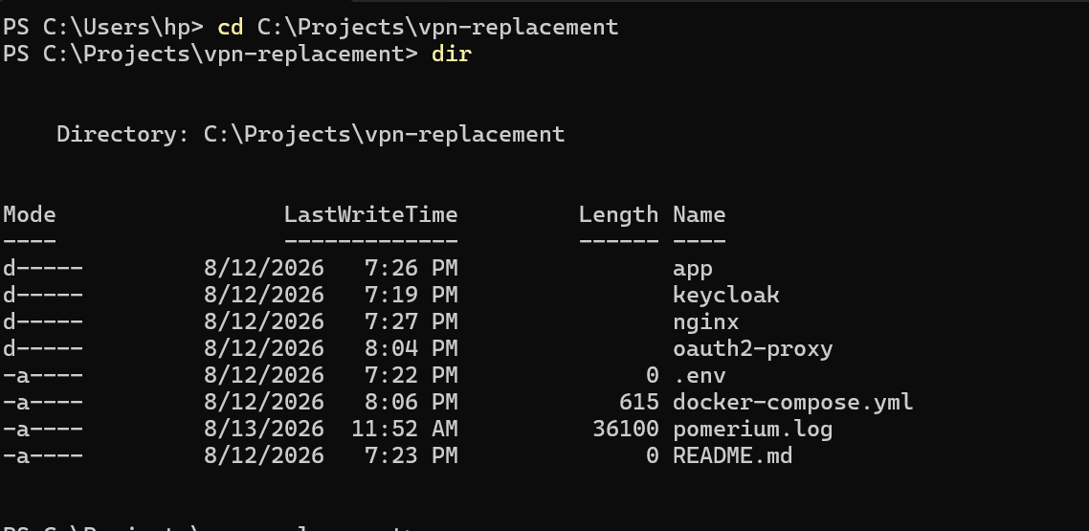
Initial project folder structure (v1) with app, keycloak, nginx, and oauth2-proxy folders
A second iteration of the folder layout replaced nginx with a dedicated cloudflared folder once the tunnel component was introduced:
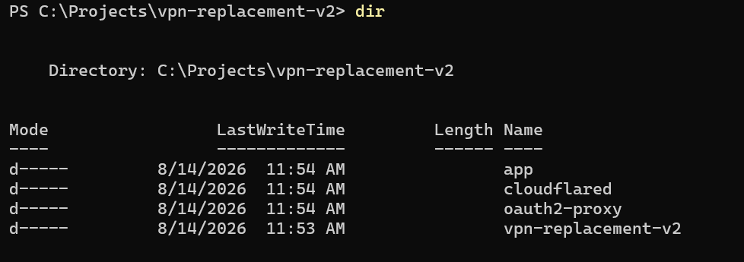
Revised project folder structure (v2) with app, cloudflared, and oauth2-proxy folders

Story 1.2: Deploying Keycloak
Keycloak is deployed as a Docker container to serve as the centralized Identity Provider for the platform.
docker run -d --name keycloak \
-p 8080:8080 \
-e KEYCLOAK_ADMIN=admin \
-e KEYCLOAK_ADMIN_PASSWORD=admin \
quay.io/keycloak/keycloak:latest start-dev

Story 1.3: Deploying the Protected Internal Application
A minimal internal web application is deployed on a local port (e.g. 127.0.0.1:3000) with no exposed network interface and no authentication logic of its own — it will later sit behind oauth2-proxy.

Story 1.4: Verifying Outbound-Only Connectivity
Before wiring in identity enforcement, a basic cloudflared quick tunnel is used to confirm outbound-only connectivity works end to end.
cloudflared tunnel --url http://127.0.0.1:3000
- Run the command above from the application host
- Open the generated public URL in a browser and confirm the application loads
- Confirm no inbound firewall rule or port forward was created
Running docker ps confirms which services are active. In this snapshot, keycloak and internal-app are Up, but oauth2-proxy is caught in a restart loop — see the Troubleshooting Notes at the end of Phase 4 for the fix.
docker ps output: keycloak (Up) and internal-app (Up) are healthy; oauth2-proxy is Restarting

Phase 2: Zero Trust Architecture Design & Technology Selection
This phase covers the research and design decisions behind ZeroTrust Gateway: why VPNs fall short, why each component was chosen, and how the per-application access model is structured.

Story 2.1: Limitations of VPN-Based Access
- An exposed VPN endpoint or open inbound port is a standing attack surface
- VPNs grant network-level access rather than application-specific access
- No continuous identity verification after the initial connection
- Once inside the network, a compromised session can often move laterally

Story 2.2: Technology Selection
- Cloudflare Tunnel (cloudflared): outbound-only connectivity layer, removing all inbound exposure
- oauth2-proxy: identity enforcement gateway placed in front of every protected application
- Keycloak: centralized, self-hosted Identity Provider issuing OIDC tokens

Story 2.3: Per-Application Access Model
Unlike a VPN, which places a user on the network, ZeroTrust Gateway scopes each oauth2-proxy instance to a single upstream application. A user authenticated for one application has no network-level path to any other internal service — access must be explicitly published and identity-gated per application.

Story 2.4: Functional & Non-Functional Requirements
- Functional: outbound-only exposure, forced authentication, OIDC integration, access denial handling, session management
- Non-Functional: zero cost (free, open-source tooling), portability across Docker hosts, TLS encryption for all public traffic, declarative and version-controllable configuration

Phase 3: Building the Secure Access Platform
This phase covers the core access-management functionality of ZeroTrust Gateway and how its components communicate securely.

Story 3.1: Internal Application Publishing
Each protected application is published through its own cloudflared tunnel and oauth2-proxy pairing, keeping publishing decisions explicit and per-application rather than network-wide.

Story 3.2: Outbound-Only Tunnel Connectivity
cloudflared is the only component that talks to the outside world, and it only ever initiates outbound connections. Cloudflare's edge terminates public TLS and relays traffic back over that outbound tunnel.

Story 3.3: Identity-Based Access Control
oauth2-proxy enforces that every request carries a valid, Keycloak-issued session before it reaches the application — access is granted based on verified identity, not network location.

Story 3.4: OIDC Authentication & Session Management
Keycloak issues signed OIDC tokens on successful login. oauth2-proxy validates these tokens and maintains a signed session cookie for the browser, so the user does not need to re-authenticate on every request.

Phase 4: Secure Identity Integration & Access Enforcement
This phase covers registering ZeroTrust Gateway's OIDC client in Keycloak and configuring oauth2-proxy to enforce authentication in front of the protected application. The Keycloak Admin Console is accessible at http://localhost:8080/admin.

Story 4.1: Realm Setup
A dedicated realm isolates this platform's users and client from any other workloads on the Keycloak instance.
- Access the Keycloak Admin Console at http://localhost:8080/admin
- Log in with the administrator credentials
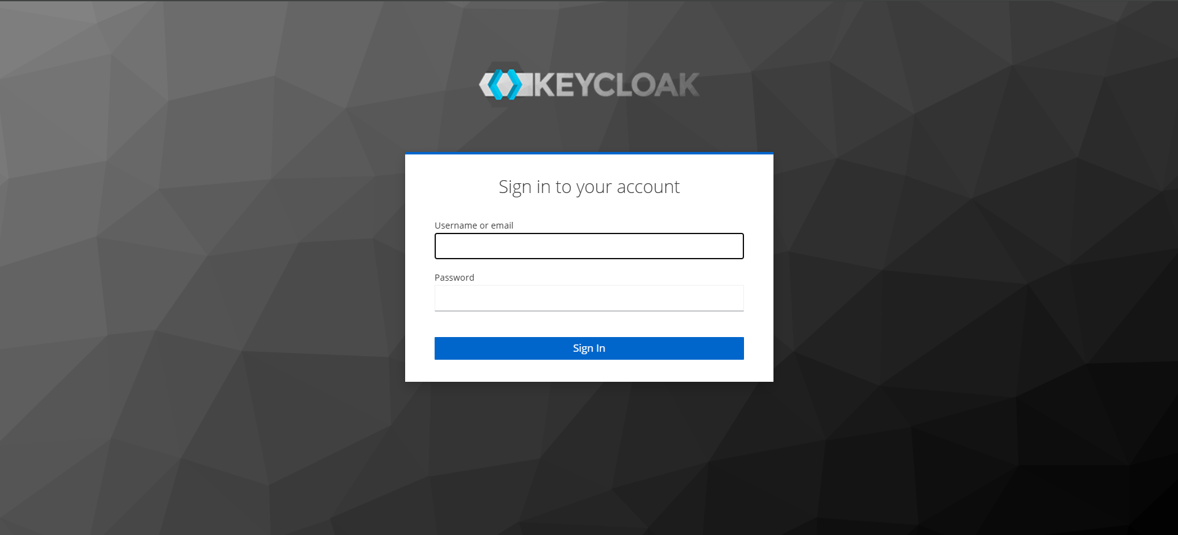
Keycloak Admin Console sign-in page
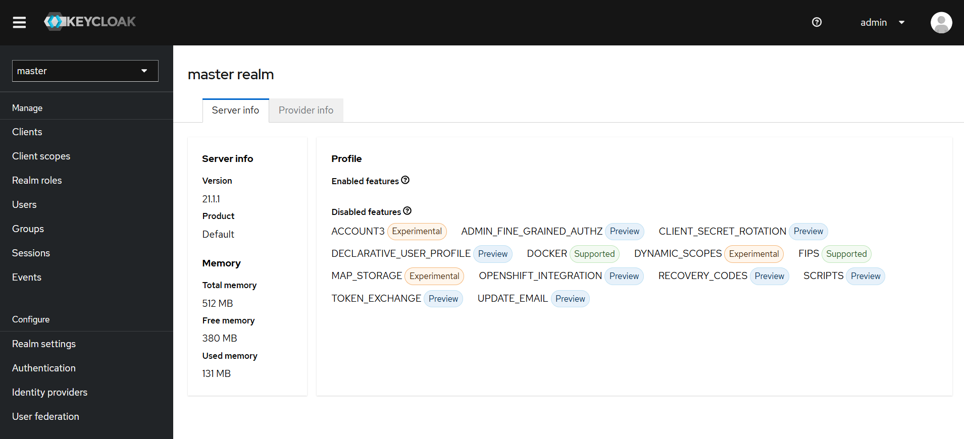
Master realm dashboard after logging in as admin
- Click the realm dropdown in the top-left corner
- Click 'Create Realm'
- Enter 'vpn-realm' as the realm name and click 'Create'
- Verify 'vpn-realm' is now selected in the top-left dropdown
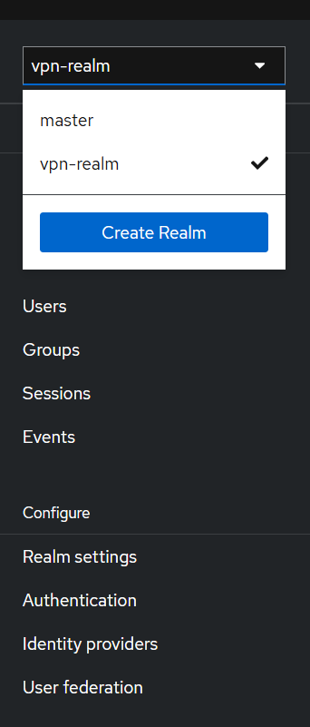
Realm dropdown confirming 'vpn-realm' is created and selected

Story 4.2: Creating Test Users
- On the left sidebar, click 'Users' then 'Add user'
- Enter the username and toggle 'Email verified' to ON
- Click 'Create'
- Go to the 'Credentials' tab then 'Set password'
- Enter the password and toggle 'Temporary' to OFF
- Click 'Save' then 'Save password'
[Screenshot placeholder: Keycloak user creation form with credentials tab open]

Story 4.3: Registering the OIDC Client
oauth2-proxy needs a registered OIDC client in Keycloak to negotiate user authentication. The client is created as 'confidential', which generates a Client Secret that oauth2-proxy uses to communicate securely with Keycloak.
- On the left sidebar, click 'Clients' then 'Create client'
- Set Client ID to 'vpn-client' and click 'Next'
- Toggle 'Client authentication' to ON (makes it a Confidential client)
- Ensure 'Standard flow' is checked, click 'Next'
- Set Valid Redirect URIs to the oauth2-proxy callback path (e.g. https://<tunnel-hostname>/oauth2/callback)
- Click 'Save'
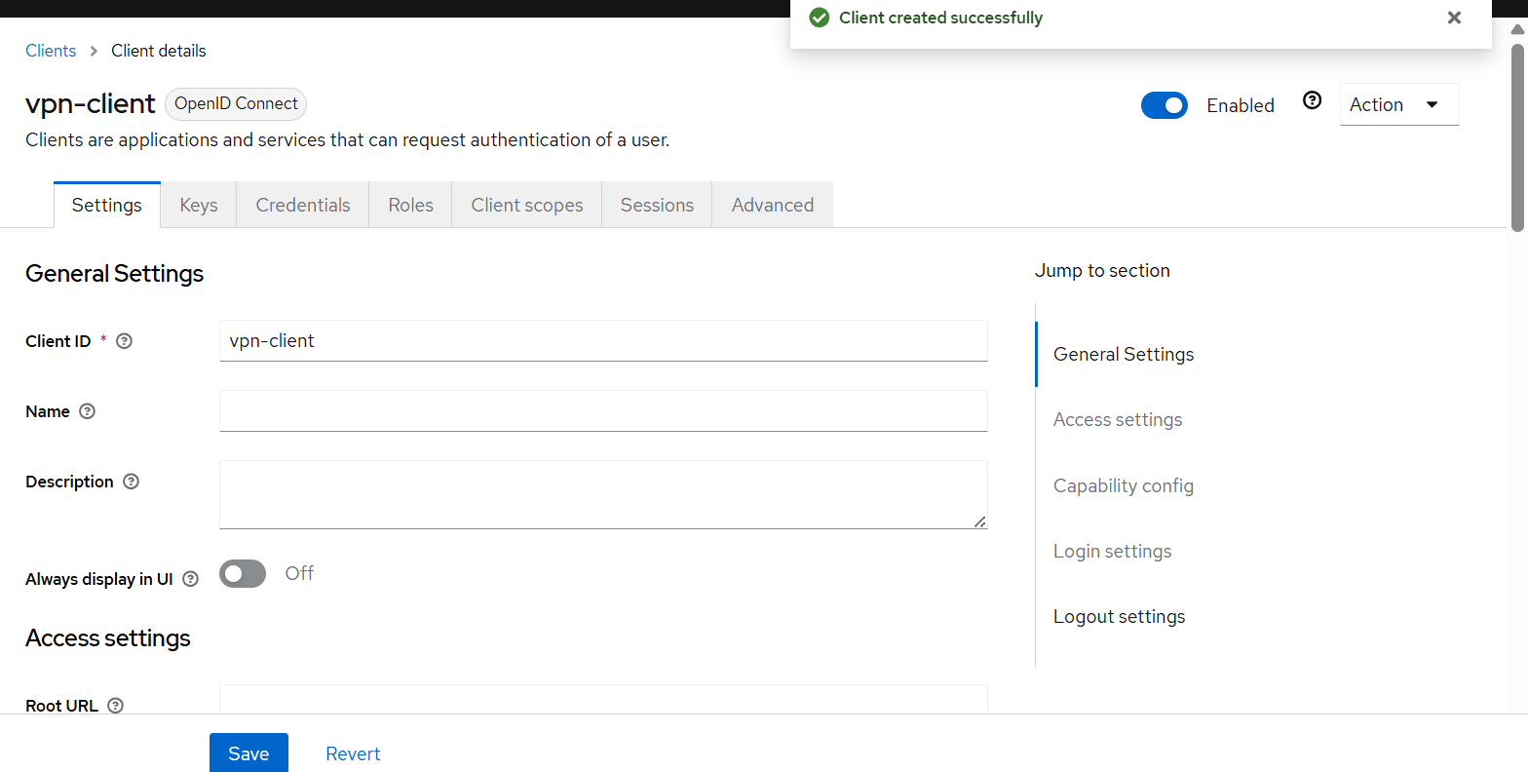
'vpn-client' created successfully in the vpn-realm realm

Story 4.4: Client Secret & oauth2-proxy Configuration
The auto-generated Client Secret is copied into oauth2-proxy's configuration so it can authenticate itself with Keycloak during OIDC token exchanges.
- Inside the vpn-client settings, click the 'Credentials' tab
- Copy the generated Client Secret
- Open oauth2-proxy/oauth2-proxy.cfg
- Paste the secret as the value of client-secret
provider = "oidc"
oidc_issuer_url = "http://localhost:8080/realms/vpn-realm"
client_id = "vpn-client"
client_secret = "<paste-from-keycloak>"
redirect_url = "https://<tunnel-hostname>/oauth2/callback"
email_domains = ["*"]
cookie_secret = "<32-byte-base64-secret>"
cookie_secure = true
upstreams = ["http://127.0.0.1:3000/"]
http_address = "127.0.0.1:4180"

Story 4.5: Validating Tokens Before Forwarding
- Generate a cookie secret: openssl rand -base64 32
- Paste the value into cookie_secret in oauth2-proxy.cfg
- Start oauth2-proxy and confirm it listens on 127.0.0.1:4180
- Navigate to http://localhost:4180 and confirm the request redirects to Keycloak login
- Log in with the test user and confirm the upstream application loads
[Screenshot placeholder: Browser showing Keycloak login redirect from oauth2-proxy]

Troubleshooting Notes
Two issues were encountered while building this phase and are documented here for reference.
Issue 1: 'Forbidden, permission needed: query-clients' in the admin console
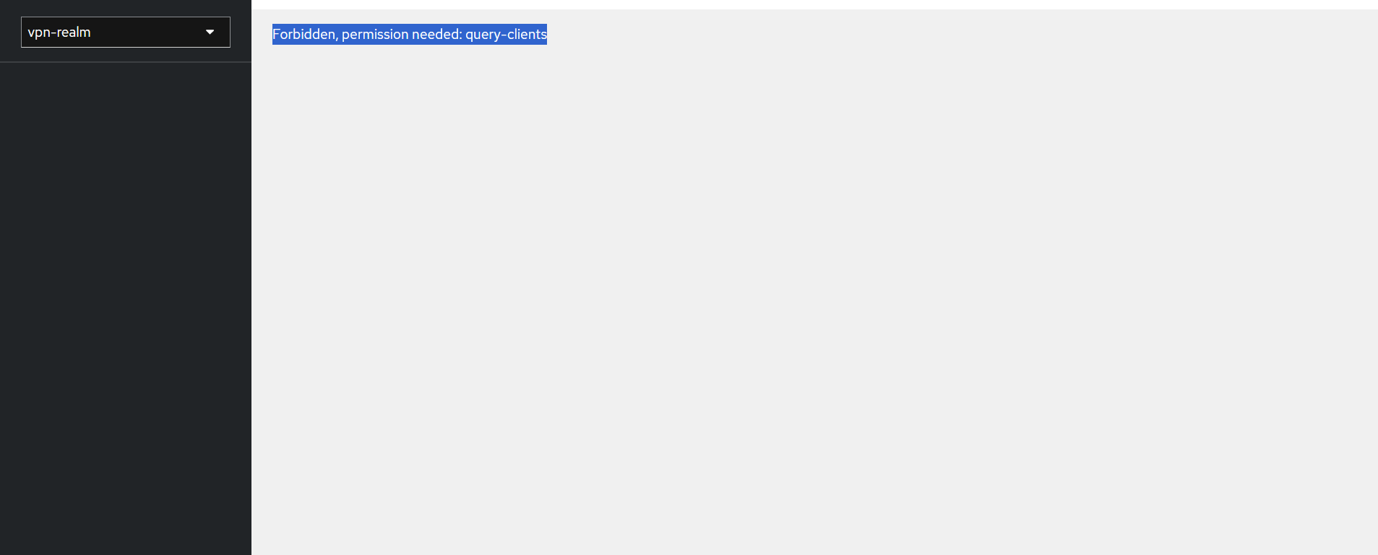
Error shown when opening Clients in vpn-realm
This error appears when the currently logged-in admin session does not have sufficient realm-management permissions to list Clients — it is a permissions/session issue, not a configuration bug in the realm itself. It typically happens after switching realms in the same browser session, or when logged in with an account that isn't the full master admin.
Fix:
- Log out completely from the Keycloak admin console (top-right account menu > Sign out)
- Clear the browser tab or open a private/incognito window
- Log back in directly at http://localhost:8080/admin with the master 'admin' account
- Switch to 'vpn-realm' from the realm dropdown and open Clients again
- If the error persists, restart the Keycloak container: docker restart keycloak
Issue 2: oauth2-proxy container stuck in a restart loop
The docker ps output in Phase 1 shows oauth2-proxy with status 'Restarting (1)', meaning the process is crashing immediately after each start — almost always caused by a configuration error rather than a networking problem.
Fix:
- Check the container's logs to see the exact startup error: docker logs oauth2-proxy
- Common causes: a missing or incorrect cookie_secret (must be a valid 32-byte base64 string), an unreachable oidc_issuer_url (Keycloak must be reachable from inside the oauth2-proxy container, not just from the host), or a client_secret that doesn't match the current value in Keycloak's Credentials tab
- If oauth2-proxy runs in its own container on a Docker network, oidc_issuer_url should point to the Keycloak service name (e.g. http://keycloak:8080/realms/vpn-realm) rather than http://localhost:8080, since 'localhost' inside a container refers to the container itself
- After correcting oauth2-proxy.cfg, recreate the container: docker-compose up -d --force-recreate oauth2-proxy

Phase 5: Zero Trust Application Access Engine
This phase integrates the full Zero Trust workflow and validates the end-to-end request path, from a public URL to the protected application, with identity verified at every step.

Story 5.1: End-to-End Request Flow
- 1. A user opens the public https://<tunnel-hostname> URL
- 2. Cloudflare's edge terminates TLS and forwards the request over the outbound tunnel to cloudflared
- 3. cloudflared forwards the request to oauth2-proxy on 127.0.0.1:4180
- 4. oauth2-proxy checks for a valid session cookie; if absent, it redirects to Keycloak
- 5. The user authenticates against the 'vpn-realm' realm in Keycloak
- 6. Keycloak issues an OIDC token; oauth2-proxy sets a signed session cookie and redirects back
- 7. oauth2-proxy forwards the now-authenticated request to the application on 127.0.0.1:3000

Story 5.2: Per-Application Authorization
Because each application has its own oauth2-proxy instance and upstream target, authorization is naturally scoped per application. Extending the platform to a second application means standing up a second oauth2-proxy + tunnel pairing, not widening network access.

Phase 6: Dynamic Access Experience & Security Controls
This phase focuses on the end-user experience and the security guarantees that come from removing VPN clients entirely.

Story 6.1: Seamless Browser-Based Access
Users reach protected applications with nothing more than a browser and their Keycloak credentials — no VPN client to install, configure, or keep connected.

Story 6.2: No Network-Level Access
Because oauth2-proxy forwards only to its single configured upstream, an authenticated user has no route to any other internal host. This is a structural difference from a VPN, which places the client on the network itself.

Story 6.3: Blocking Unauthorized Requests
Any request without a valid session is redirected to Keycloak and never reaches the upstream application, so unauthenticated traffic cannot probe or interact with internal services.

Phase 7: Deployment Using Cloudflare Tunnel & Self-Hosted Identity
This phase covers publishing the fully identity-gated application to the public internet using cloudflared, without opening any inbound firewall port and without purchasing a domain.

Story 7.1: Installing cloudflared
# macOS
brew install cloudflare/cloudflare/cloudflared
# Linux (Debian/Ubuntu)
curl -L https://github.com/cloudflare/cloudflared/releases/latest/download/cloudflared-linux-amd64.deb -o cloudflared.deb
sudo dpkg -i cloudflared.deb

Story 7.2: Publishing Through the Identity Gate
The tunnel is pointed at oauth2-proxy's local address (127.0.0.1:4180), not directly at the application — this ensures every public request passes through the identity gate first.
cloudflared tunnel --url http://127.0.0.1:4180
- Run the command above from the application host
- Note the generated public tunnel URL printed in the terminal
- Confirm no inbound firewall rule or port forward was created
[Screenshot placeholder: Terminal output showing the generated tunnel URL]

Story 7.3: Verifying Outbound-Only, Domain-Free Exposure
- From a separate network (e.g. mobile data), open the public tunnel URL
- Verify the Keycloak login page loads over HTTPS
- Run a port scan against the application host's public IP and confirm no port is open

Phase 8: Testing, Monitoring & Security Validation

Story 8.1: Test Data Preparation
One or more test user accounts are prepared in the 'vpn-realm' Keycloak realm to validate both the unauthenticated and authenticated paths.

Story 8.2: Functional Test Workflow
- Navigate to the public tunnel URL in a private browser window
- Verify the request redirects to the Keycloak login page
- Attempt to access the application URL directly without logging in — verify access is denied
- Log in with valid test-user credentials
- Verify the browser is redirected back and the internal application loads
- Refresh the page and confirm no re-authentication is required (session cookie active)
- Sign out via oauth2-proxy's sign-out endpoint and confirm the session is terminated
- Attempt to reload the application — verify it redirects to Keycloak login again
- Enter incorrect credentials on the Keycloak login page and verify an error is shown with no session created

Story 8.3: Security & Trust Boundary Validation
- No Inbound Exposure: A port scan of the host's public IP shows no open inbound port; cloudflared's connection is outbound-only
- Trust Boundary Check: Confirm the application has no direct network exposure outside the oauth2-proxy upstream link
- Session Integrity: Confirm session cookies are marked Secure and HttpOnly, and are invalidated on sign-out
- Zero Cost: The entire stack (cloudflared, oauth2-proxy, Keycloak) runs on free tooling with no domain purchase

Story 8.4: Functional Testing Results
- Unauthenticated Access Redirect: Navigating to the application URL without a session correctly redirects to Keycloak login
- Session Persistence: After logging in once, subsequent requests do not require re-authentication until the session expires or sign-out occurs
- Sign-Out: Using oauth2-proxy's sign-out endpoint correctly terminates the session; the next request redirects to Keycloak login
- Invalid Credentials: Entering an incorrect username or password displays an error and creates no session

Outcome
By completing this project, you will:
- Build a Zero Trust Network Access (ZTNA) platform using Cloudflare Tunnel and Keycloak
- Implement identity-based application access without VPNs
- Gain hands-on experience with OpenID Connect (OIDC), oauth2-proxy, and identity federation
- Eliminate exposed inbound ports through outbound-only secure tunneling
- Develop secure authentication and authorization workflows for internal applications
- Implement per-application access control aligned with Zero Trust principles
- Perform security analysis, threat modeling, and access validation
- Understand modern VPN-replacement technologies used in enterprise cybersecurity environments

Conclusion
ZeroTrust Gateway has been successfully designed as a complete, self-hosted Zero Trust Network Access platform that removes the need for a traditional VPN. By combining an outbound-only tunnel (cloudflared) with a self-hosted identity gate (oauth2-proxy backed by Keycloak), the system enforces the principle of 'never trust, always verify' while exposing zero inbound ports and requiring no domain purchase.
A key achievement is proving that the per-application, identity-verified access pattern used by commercial ZTNA products can be reproduced with free, self-hosted, open-source components — without any paid product or owned domain.
Key Achievements:
- Published an internal application to the public internet with zero inbound firewall rules using cloudflared
- Enforced authentication at the edge using oauth2-proxy, with no authentication code inside the protected application
- Deployed and integrated Keycloak as a centralized, self-hosted Identity Provider via OIDC
- Achieved a session-based login experience where users authenticate once and remain signed in until sign-out or expiry
- Verified complete access enforcement through end-to-end testing covering unauthenticated access, login, session persistence, and sign-out
- Delivered the entire solution using free, open-source components with no domain purchase required
Looking ahead, the project offers opportunities for expansion, such as replacing the free quick tunnel with a named Cloudflare Tunnel for a stable hostname, adding Multi-Factor Authentication (MFA) in Keycloak via OTP or WebAuthn, introducing device posture checks as an additional access condition, and centralizing oauth2-proxy and Keycloak access logs for monitoring and compliance auditing.

